Coronavirus disease 2019 (COVID-19)
Situation Report – 38

Data as reported by 10AM CET 27 February 2020*

HIGHLIGHTS

- Nine new Member States (Brazil, Denmark, Estonia, Georgia, Greece, Norway, Pakistan, Romania, and North Macedonia) reported cases of COVID-19 in the past 24 hours.

- WHO and the World Tourism Organization released a joint statement regarding responsibility and coordination on tourism and COVID-19. For more information, please visit this webpage.

- OpenWHO, a web-based learning platform, has launched the free online courses Introduction to Emerging Respiratory Viruses, Including Novel Coronovirus, in Portuguese and Health and Safety Briefing for Respiratory Diseases – ePROTECT in French today.

- WHO is utilizing an international network of expert laboratories to provide support in the detection of the COVID-19 virus globally. For more information, please see the Subject in Focus below.
China | Very High
Regional Level | High
Global Level | High

SITUATION IN NUMBERS
total and new cases in last 24 hours

Globally
82 294 confirmed (1185 new)

China
78 630 confirmed (439 new)
2747 deaths (29 new)

Outside of China
3664 confirmed (746 new)
46 countries (9 new)
57 deaths (13 new)

WHO RISK ASSESSMENT

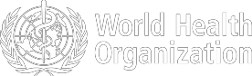

Figure 1. Countries, territories or areas with reported confirmed cases of COVID-19, 27 February 2020

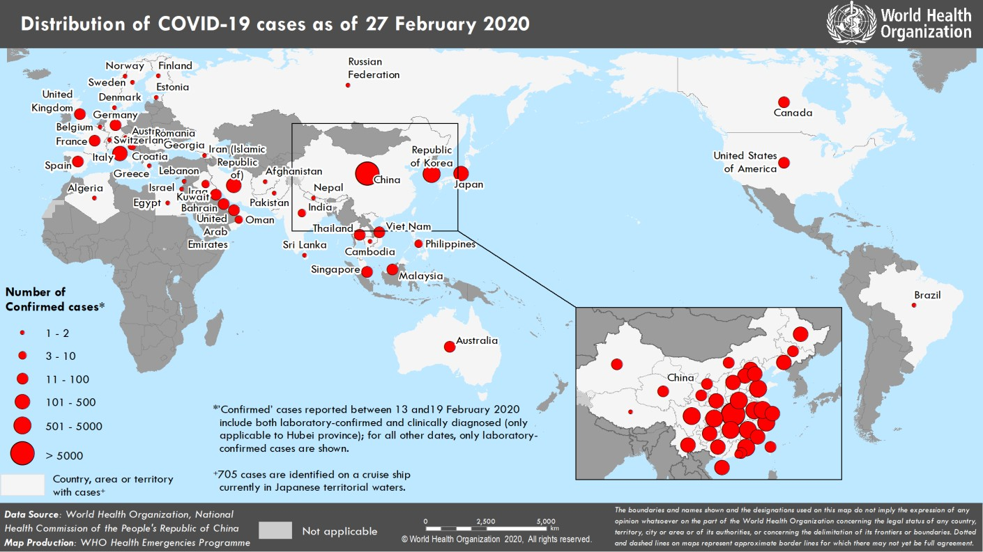

SITUATION IN FOCUS: Laboratory Network and Detection

On 9 January 2020, WHO published interim laboratory guidance for detection of the novel coronavirus. This guidance is continually updated as more data becomes available and includes advice on sample collection, diagnostic testing, and pathogen characterization. Specific interim guidance on biosafety in the laboratory has also been published. An update to the guidance for the international shipment of specimens will follow soon. WHO is utilizing an international network of expert laboratories to provide support in the detection of the COVID-19 virus globally.
Figure 2. WHO international reference laboratories for the COVID-19 virus.
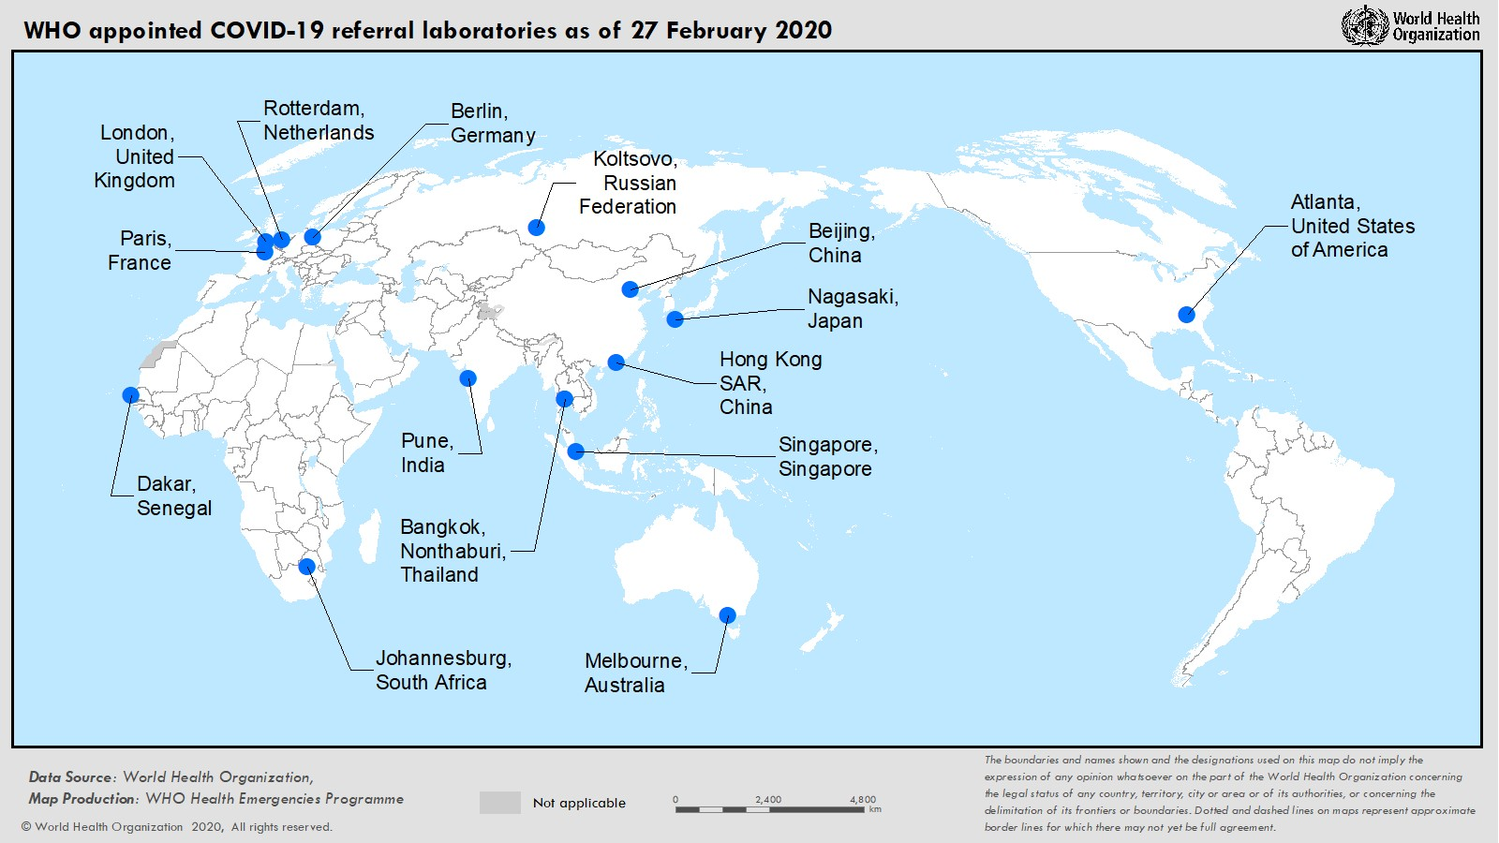
The diagnostic landscape of this outbreak is changing quickly. The first COVID-19 cases were detected using genomic sequencing, but multiple RT-PCR commercial and non-commercial assays have since been developed. As the international case load increases, there is an urgent need to rapidly scale up diagnostic capacity to detect and confirm cases of COVID-19. WHO has taken a three-pronged approach to enhance global diagnostic capacity for the COVID-19 virus:
- Developing a WHO network of 15 COVID-19 reference laboratories with demonstrated expertise in the molecular detection of coronaviruses. These international laboratories can support national labs to confirm the COVID-19 virus and troubleshoot their molecular assays.
- Strengthening national capacity for detection of the COVID-19 virus so that diagnostic testing can be performed rapidly without the need for overseas shipping. Existing global networks for detection of respiratory pathogens are being utilized including, notably, the National Influenza Centers that support the Global Influenza Surveillance and Response System.
- Ensuring ongoing test availability. WHO has procured a commercial assay (manufactured under ISO:13485) with strong performance data and shipped to over 150 laboratories globally as an interim measure for Member States requesting support. The main goal is to strengthen global diagnostic capacity for detection of the COVID-19 virus. Support is now also provided to ensure the quality of testing through the implementation of an External Quality Assurance mechanism.
Public health efforts are targeted at both interrupting further transmission and monitoring the spread of COVID-19. As reports of asymptomatic cases increase, the need for reliable serology testing is becoming more urgent. There are a number of groups working on this and developments are being monitored.
SURVEILLANCE

Table 1. Confirmed and suspected cases of COVID-19 acute respiratory disease reported by provinces, regions and cities in China, 27 February 2020
Province/ Region/ | Population (10,000s) | Confirmed | Daily  Suspected |  | Cumulative  Confirmed
City | cases |  | cases | Deaths | cases |  | Deaths
Hubei | 5917 | 409 | 403 | 26 | 65596 |  | 2641
Guangdong | 11346 | 0 | 0 | 0 | 1347 |  | 7
Henan | 9605 | 1 | 2 | 1 | 1272 |  | 20
Zhejiang | 5737 | 0 | 0 | 0 | 1205 |  | 1
Hunan | 6899 | 1 | 0 | 0 | 1017 |  | 4
Anhui | 6324 | 0 | 0 | 0 | 989 |  | 6
Jiangxi | 4648 | 0 | 0 | 0 | 934 |  | 1
Shandong | 10047 | 0 | 0 | 0 | 756 |  | 6
Jiangsu | 8051 | 0 | 0 | 0 | 631 |  | 0
Chongqing | 3102 | 0 | 11 | 0 | 576 |  | 6
Sichuan | 8341 | 3 | 4 | 0 | 534 |  | 3
Heilongjiang | 3773 | 0 | 0 | 1 | 480 |  | 13
Beijing | 2154 | 10 | 10 | 1 | 410 |  | 5
Shanghai | 2424 | 1 | 33 | 0 | 337 |  | 3
Hebei | 7556 | 5 | 0 | 0 | 317 |  | 6
Fujian | 3941 | 2 | 0 | 0 | 296 |  | 1
Guangxi | 4926 | 0 | 0 | 0 | 252 |  | 2
Shaanxi | 3864 | 0 | 0 | 0 | 245 |  | 1
Yunnan | 4830 | 0 | 3 | 0 | 174 |  | 2
Hainan | 934 | 0 | 4 | 0 | 168 |  | 5
Guizhou | 3600 | 0 | 1 | 0 | 146 |  | 2
Tianjin | 1560 | 0 | 20 | 0 | 135 |  | 3
Shanxi | 3718 | 0 | 1 | 0 | 133 |  | 0
Liaoning | 4359 | 0 | 14 | 0 | 121 |  | 1
Jilin | 2704 | 0 | 2 | 0 | 93 |  | 1
Gansu | 2637 | 0 | 0 | 0 | 91 |  | 2
Hong Kong SAR | 745 | 6 | 0 | 0 | 91 |  | 2
Xinjiang | 2487 | 0 | 0 | 0 | 76 |  | 2
Inner Mongolia | 2534 | 0 | 0 | 0 | 75 |  | 0
Ningxia | 688 | 1 | 0 | 0 | 72 |  | 0
Taipei and environs | 2359 | 0 | 0 | 0 | 32 |  | 1
Qinghai | 603 | 0 | 0 | 0 | 18 |  | 0
Macao SAR | 66 | 0 | 0 | 0 | 10 |  | 0
Xizang | 344 | 0 | 0 | 0 | 1 |  | 0
Total | 142823 | 439 | 508 | 29 | 78630 |  | 2747

Table 2. Countries, territories or areas outside China with reported laboratory-confirmed COVID-19 cases and deaths. Data as of 27 February 2020

Likely place of exposure†
Outside
* In

Total cases with site of

Total

Country/Territory/Area Confirmed
cases (new)

Western Pacific Region
Republic of Korea 1766 (505)
Japan 186 (22)
Singapore 93 (2)
Australia 23 (0)
Malaysia 22 (0)
Viet Nam 16 (0)
Philippines 3 (0)
Cambodia 1 (0)
South-East Asia Region
Thailand 40 (0)
India 3 (0)
Nepal 1 (0)
Sri Lanka 1 (0)
Region of the Americas
United States of America 59 (6)
Canada 11 (1)
Brazil 1 (1)
European Region
Italy 400 (78)
Germany 21 (3)
France 18 (6)
The United Kingdom 13 (0)
Spain 12 (10)
Croatia 3 (1)
Austria 2 (0)
Finland 2 (1)
Israel 2 (0)
Russian Federation 2 (0)
Sweden 2 (1)
Belgium 1 (0)
Denmark 1 (1)
Estonia 1 (1)
Georgia 1 (1)
Greece 1 (1)
North Macedonia 1 (1)
Norway 1 (1)
Romania 1 (1)
Switzerland 1 (0)
Eastern Mediterranean Region
Iran (Islamic Republic of) 141 (46)
Kuwait 43 (31)
Bahrain 33 (7)
United Arab Emirates 13 (0)
Iraq 6 (1)
Oman 4 (0)
China (new)
reporting
country and outside China (new)
13 (0) | 4 (0) | 605 (0) | 1144 (505) | 13 (1)
28 (0) | 11 (3) | 129 (13) | 18 (6) | 3 (2)
24 (0) | 0 (0) | 69 (2) | 0 (0) | 0 (0)
12 (0) | 8 (0) | 3 (0) | 0 (0) | 0 (0)
18 (0) | 2 (0) | 2 (0) | 0 (0) | 0 (0)
8 (0) | 0 (0) | 8 (0) | 0 (0) | 0 (0)
3 (0) | 0 (0) | 0 (0) | 0 (0) | 1 (0)
1 (0) | 0 (0) | 0 (0) | 0 (0) | 0 (0)
23 (0) | 0 (0) | 7 (0) | 10 (0) | 0 (0)
3 (0) | 0 (0) | 0 (0) | 0 (0) | 0 (0)
1 (0) | 0 (0) | 0 (0) | 0 (0) | 0 (0)
1 (0) | 0 (0) | 0 (0) | 0 (0) | 0 (0)
14 (0) | 42 (6) | 2 (0) | 1 (0) | 0 (0)
7 (0) | 2 (1) | 1 (0) | 1 (0) | 0 (0)
0 (0) | 1 (1) | 0 (0) | 0 (0) | 0 (0)
3 (0) | 0 (0) | 121 (0) | 276 (78) | 12 (1)
2 (0) | 1 (1) | 14 (0) | 4 (2) | 0 (0)
6 (1) | 2 (2) | 7 (0) | 3 (3) | 2 (1)
2 (0) | 10 (0) | 1 (0) | 0 (0) | 0 (0)
0 (0) | 10 (8) | 1 (1) | 1 (1) | 0 (0)
0 (0) | 2 (1) | 1 (0) | 0 (0) | 0 (0)
0 (0) | 2 (0) | 0 (0) | 0 (0) | 0 (0)
1 (0) | 1 (1) | 0 (0) | 0 (0) | 0 (0)
0 (0) | 2 (0) | 0 (0) | 0 (0) | 0 (0)
2 (0) | 0 (0) | 0 (0) | 0 (0) | 0 (0)
1 (0) | 1 (1) | 0 (0) | 0 (0) | 0 (0)
1 (0) | 0 (0) | 0 (0) | 0 (0) | 0 (0)
0 (0) | 1 (1) | 0 (0) | 0 (0) | 0 (0)
0 (0) | 0 (0) | 0 (0) | 1 (1) | 0 (0)
0 (0) | 1 (1) | 0 (0) | 0 (0) | 0 (0)
0 (0) | 1 (1) | 0 (0) | 0 (0) | 0 (0)
0 (0) | 1 (1) | 0 (0) | 0 (0) | 0 (0)
1 (1) | 0 (0) | 0 (0) | 0 (0) | 0 (0)
0 (0) | 1 (1) | 0 (0) | 0 (0) | 0 (0)
0 (0) | 1 (0) | 0 (0) | 0 (0) | 0 (0)
0 (0) | 0 (0) | 28 (0) | 113 (46) | 22 (7)
0 (0) | 43 (31) | 0 (0) | 0 (0) | 0 (0)
0 (0) | 33 (7) | 0 (0) | 0 (0) | 0 (0)
6 (0) | 2 (0) | 5 (0) | 0 (0) | 0 (0)
0 (0) | 6 (1) | 0 (0) | 0 (0) | 0 (0)
0 (0) | 4 (0) | 0 (0) | 0 (0) | 0 (0)

reporting country (new)
transmission under investigation (new)
deaths (new)

Lebanon | 2 (1) | 0 (0) | 1 (0) | 0 (0) | 1 (1) | 0 (0)
Pakistan | 2 (2) | 0 (0) | 2 (2) | 0 (0) | 0 (0) | 0 (0)
Afghanistan | 1 (0) | 0 (0) | 1 (0) | 0 (0) | 0 (0) | 0 (0)
Egypt | 1 (0) | 0 (0) | 0 (0) | 1 (0) | 0 (0) | 0 (0)
African Region
Algeria | 1 (0) | 0 (0) | 1 (0) | 0 (0) | 0 (0) | 0 (0)
Subtotal for all regions | 2959 (732) | 181 (2) | 200 (71) | 1005 (16) | 1573 (643) | 53 (12)
International conveyance‡ (Diamond Princess) | 705 (14) | 0 (0) | 0 (0) | 0 (0) | 0 (0) | 4 (1)
Grand total§ | 3664 (746) | 181 (2) | 200 (71) | 1005 (16) | 1573 (643) | 57 (13)
*Case classifications are based on WHO case definitions for COVID-19.
†Location of transmission is classified based on WHO analysis of available official data and may be subject to reclassification as additional data become available.
‡Cases identified on a cruise ship currently in Japanese territorial waters.
§234 female/331 male/3099 unknown. 26 healthcare workers (5 female/11 male/ 10 unknown).
Figure 3. Epidemic curve of COVID-19 cases (n=338) identified outside of China, by date of onset of symptoms and likely exposure location, 27 February 2020

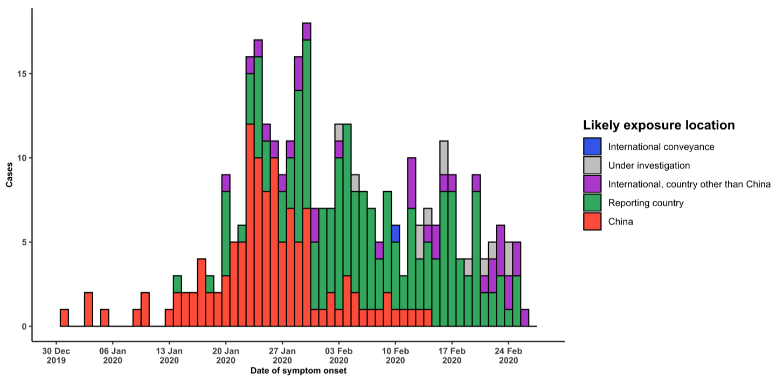
Note for figure 2: Of the 3664 cases reported outside China, 92 were detected while apparently asymptomatic. For the remaining 3572 cases, information on date of onset is available only for the 338 cases presented in the epidemiologic curve.

Figure 4. Epidemic curve of COVID-19 cases (n=3664) identified outside of China, by date of report and likely exposure location, 27 February 2020

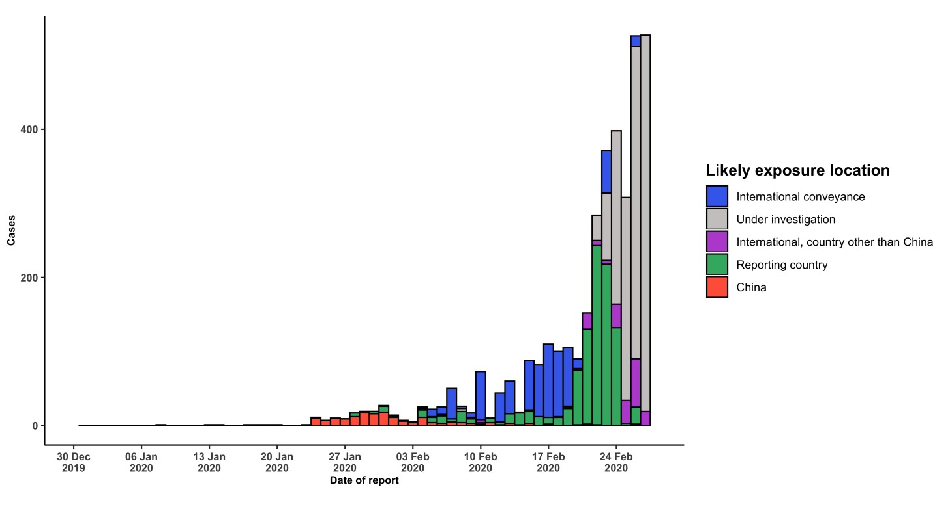
STRATEGIC OBJECTIVES

WHO’s strategic objectives for this response are to:

  - Interrupt human-to-human transmission including reducing secondary infections among close contacts and health care workers, preventing transmission amplification events, and preventing further international spread*;
  - Identify, isolate and care for patients early, including providing optimized care for infected patients;
  - Identify and reduce transmission from the animal source;
  - Address crucial unknowns regarding clinical severity, extent of transmission and infection, treatment options, and accelerate the development of diagnostics, therapeutics and vaccines;
  - Communicate critical risk and event information to all communities and counter misinformation;
  - Minimize social and economic impact through multisectoral partnerships.

*This can be achieved through a combination of public health measures, such as rapid identification, diagnosis and management of the cases, identification and follow up of the contacts, infection prevention and control in health care settings, implementation of health measures for travelers, awareness-raising in the population and risk communication.

PREPAREDNESS AND RESPONSE

- To view all technical guidance documents regarding COVID-19, please go to this webpage.
- WHO is working closely with International Air Transport Association (IATA) and have jointly developed a guidance document to provide advice to cabin crew and airport workers, based on country queries. The guidance can be found on the IATA webpage.
- WHO has developed a protocol for the investigation of early cases (the “First Few X (FFX) Cases and contact investigation protocol for 2019-novel coronavirus (2019-nCoV) infection”). The protocol is designed to gain an early understanding of the key clinical, epidemiological and virological characteristics of the first cases of COVID- 19 infection detected in any individual country, to inform the development and updating of public health guidance to manage cases and reduce potential spread and impact of infection.
- WHO has been in regular and direct contact with Member States where cases have been reported. WHO is also informing other countries about the situation and providing support as requested.
- WHO has developed interim guidance for laboratory diagnosis, advice on the use of masks during home care and in health care settings in the context of the novel coronavirus (2019-nCoV) outbreak, clinical management, infection prevention and control in health care settings, home care for patients with suspected novel coronavirus, risk communication and community engagement and Global Surveillance for human infection with novel coronavirus (2019-nCoV).
- WHO has prepared disease commodity package that includes an essential list of biomedical equipment, medicines and supplies necessary to care for patients with 2019-nCoV.
- WHO has provided recommendations to reduce risk of transmission from animals to humans.
- WHO has published an updated advice for international traffic in relation to the outbreak of the novel coronavirus 2019-nCoV.
- WHO has activated of R&D blueprint to accelerate diagnostics, vaccines, and therapeutics.
- WHO has developed online courses on the following topics: A general introduction to emerging respiratory viruses, including novel coronaviruses (available in French, Chinese, Spanish, and Portuguese); Critical Care of Severe Acute Respiratory Infections; and Health and safety briefing for respiratory diseases - ePROTECT (available in French); Infection Prevention and Control for Novel Coronavirus (COVID-19); Critical Care Severe Acute Respiratory Infection
- WHO is providing guidance on early investigations, which are critical to carry out early in an outbreak of a new virus. The data collected from the protocols can be used to refine recommendations for surveillance and case definitions, to characterize the key epidemiological transmission features of COVID-19, help understand spread, severity, spectrum of disease, impact on the community and to inform operational models for implementation of countermeasures such as case isolation, contact tracing and isolation. Several protocols are available here: https://www.who.int/emergencies/diseases/novel-coronavirus-2019/technical-guidance/early-investigations
- WHO is working with its networks of researchers and other experts to coordinate global work on surveillance, epidemiology, modelling, diagnostics, clinical care and treatment, and other ways to identify, manage the disease and interrupt onward transmission. WHO has issued interim guidance for countries, which are updated regularly.
- WHO is working with global expert networks and partnerships for laboratory, infection prevention and control, clinical management and mathematical modelling.

RECOMMENDATIONS AND ADVICE FOR THE PUBLIC

If you are not in an area where COVID-19 is spreading, or if you have not travelled from one of those areas or have not been in close contact with someone who has and is feeling unwell, your chances of getting it are currently low. However, it’s understandable that you may feel stressed and anxious about the situation. It’s a good idea to get the facts to help you accurately determine your risks so that you can take reasonable precautions. (See Frequently Asked Questions) Your healthcare provider, your national public health authority and your employer are all potential sources of accurate information on COVID-19 and whether it is in your area. It is important to be informed of the situation where you live and take appropriate measures to protect yourself. (See Protection measures for everyone).
If you are in an area where there is an outbreak of COVID-19 you need to take the risk of infection seriously. Follow the advice issued by national and local health authorities. Although for most people COVID-19 causes only mild illness, it can make some people very ill. More rarely, the disease can be fatal. Older people, and those with pre- existing medical conditions (such as high blood pressure, heart problems or diabetes) appear to be more vulnerable. (See Protection measures for persons who are in or have recently visited (past 14 days) areas where COVID-19 is spreading).

